**1. SINGAPORE SLING**

* 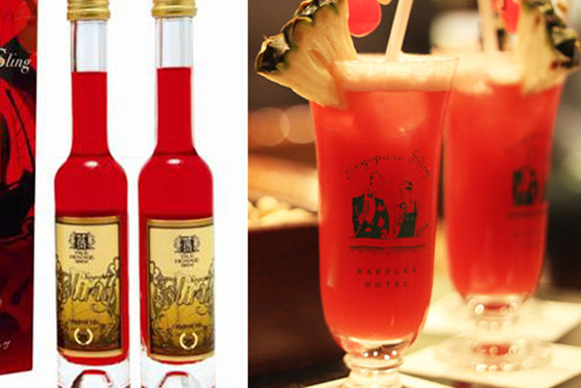

Singapore Sling is well known as the national drink of Singapore, created by bartender Ngiam Tong Boon at Raffles Hotel’s Long Bar in the 1930s and has become popular worldwide so far. Originally, this Singapore Sling simply included gin, cherry brandy, orange juice, lime juice, and pineapple juice but now there are numerous recipes for you to choose from with this famous cocktail. Its bottled versions are certainly a great gift for your loved ones.

**Price range:** From S$30.00 to S$80.00

**Where to buy**  
– Raffles Hotel’s Long Bar  
– Raffles Hotel’s souvenir shops  
– Changi Airport souvenir shops  
– Drink shops and supermarkets island wide

**2. GOLD PLATED ORCHID FROM RISIS**

* 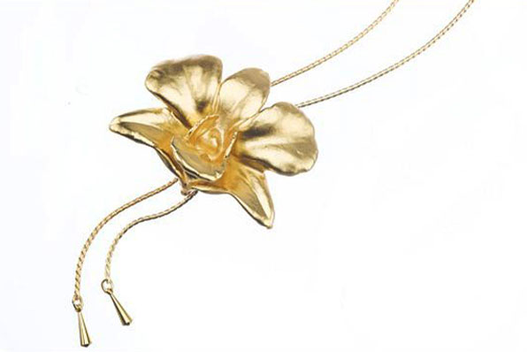Image: Gold Plated Orchid from RISIS

If you are looking for something premium unique Singaporean for someone special, just think of a plated orchid. Orchid is one of the most beautiful flowers in the world and it is the national flower of Singapore. Gold plated orchid products from RISIS are real orchids plated in 24K gold. Those golden flowers are then used to make beautiful jewelleries like earrings, pendants, necklaces, and brooches, as well as formal corporate gifts such as card and pen holders, display plates, and picture frames.

**Price range:** From S$60.00 onwards

**Where to buy**  
RISIS stores at  
– Gardens By The Bay  
– Takashimaya at Ngee Ann City Shopping Centre  
– The Shoppes at Marina Bay Sands  
– Suntec City Mall  
– National Orchid Garden at Singapore Botanic Gardens  
– Tangs Orchard  
– Tangs VivoCity  
– Changi Airport, Terminal 3

**3. BAKKWA (BBQ MEAT)**

* 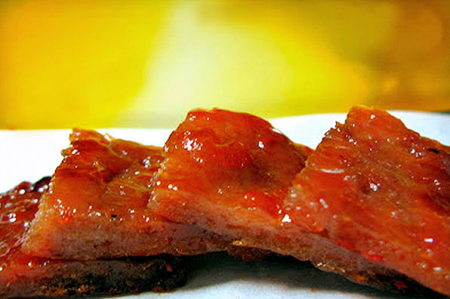Image: Bakkwa (BBQ Meat)

Among popular Singapore souvenirs, Bakkwa is an edible gift item that you can buy for your relatives and friends. Bakkwa is often made from pork, or beef which are well marinated with sugar, soy sauce and spices, and grilled over charcoal. This barbecued sliced meat dish is also a favorite snack of locals and it has become a traditional gift that our Singaporeans give parents and friends on Chinese New Year festival.

**Price range:** From S$45.00 to S$70.00 per kg

**Where to buy**  
– Bee Cheng Hiang | http://www.beechenghiang.com.sg/store-locator.html/  
– Kim Hock Guan | http://www.kimhockguan.com.sg/contact-us  
– Fragrance Foodstuff | http://www.fragrance.com.sg/index.php/Our%20Retail  
– Kim Joo Guan | http://www.kimjooguan.com/contact-us.html  
– Lim Chee Guan | http://www.limcheeguan.com.sg/

**4. KAYA (COCONUT JAM)**

* 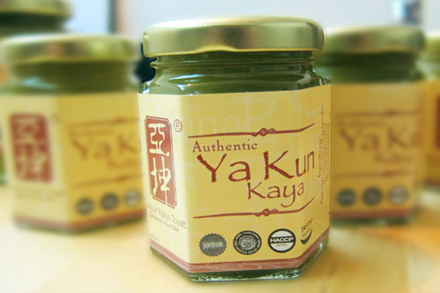Image: Ya Kun

Kaya toast is widely recognized as a national breakfast dish of Singaporeans, in which the toasted bread is filled with butter and kaya, a jam made from eggs, sugar, coconut milk, and pandan leaves. This flavourful jam is also used as a topping for several desserts and cakes. You can buy kaya jars at most supermarkets in Singapore.

**Price range:** From S$5.00 to S$10.00 per jar

**Where to buy**  
– Ya Kun Kaya Toast | http://yakun.com/find-us/local/  
– Changi Airport souvenir shops  
– Supermarkets island wide